A2035-**Eur-Slovenia-Pekarna-Brown Bear Canine-Late Paleolithic-**20,000 BP

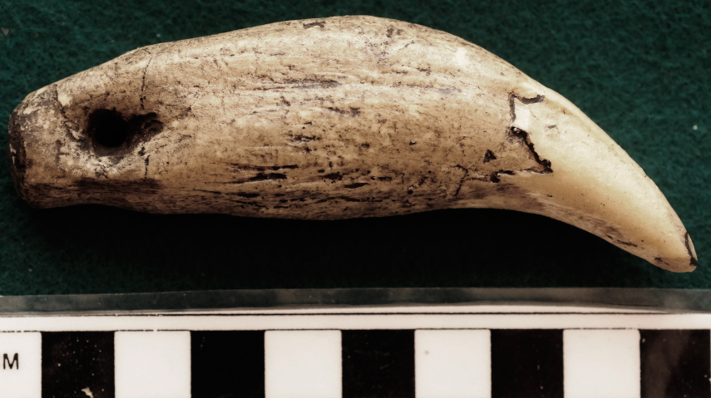

**Display description:**

**Brown bear canine used as a pendant.**

Pekarna Cave

**Accession Number:**

**LC Classification:**

**Date or Time Horizon:** 40,000 BP-29,000 BP

**Geographical Area:**

**Map, GPS Coordinates:**

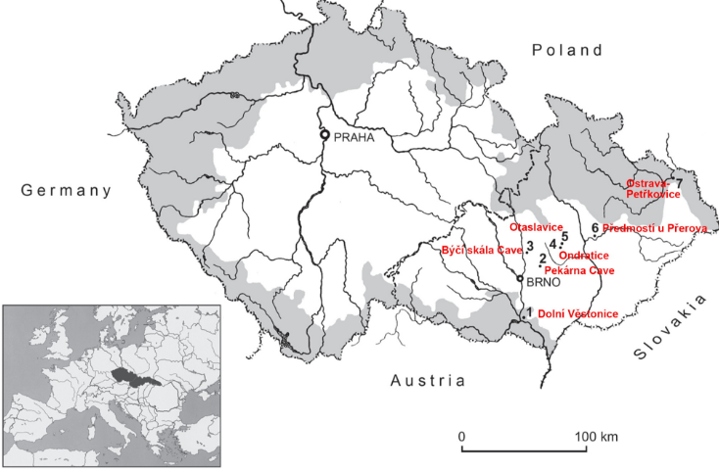

Frontier areas are marked in grey – so-called 'Sudety' – which became part of Germany from 30.09.1938 to 9.05.1945 due to the 'Munich Agreement'. The reduced territory existed from 30.09.1938 to 14.03.1939 as the so-called 'Second Republic'. From 15.03.1939 to 9.06.1945 this area was changed into the 'Protectorate of Bohemia and Moravia'. The Slovak part of the state in the East (indicated only on the downscaled map of Europe) became an independent republic.  
  
Photo: after [Kostrhuna (2009)](https://www.donsmaps.com/venuspekarna.html" \l "reference)

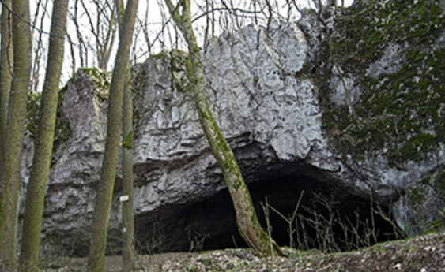

Photo: Dezidor  
Permission: Creative Commons Attribution 3.0 Unported license.

**Cultural Affiliation:** Aurignacian

**Medium:** mammoth ivory

**Dimensions:   
Weight:**

**Provenance: original,**

**Discussion:**